

JOIN A TEST MEETING:

[Cisco webex | Test online meeting](https://www.webex.com/test-meeting.html) <https://www.webex.com/test-meeting.html>

PARTICIPANTS

Join Meeting

You can join a meeting from your computer, mobile device, phone, or a video system. Choose the one that works best for you.

When you click the join link in your email invite, the **Webex Meetings app** automatically downloads. You can also download it from webex.com

If you want to join without downloading anything, **join from your browser**.

**Webex Meetings App:**

1. Open your email invite/calendar event and click the link to join meeting (should be a hyperlink – you can also copy and paste into an internet browser window)
2. 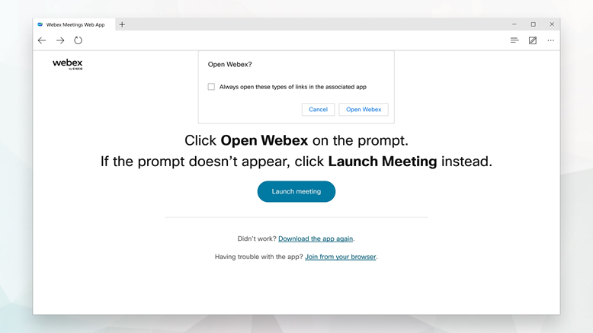Click Open Webex if you're prompted to do so, otherwise click Launch meeting.
3. Enter your name as you want it to appear in the meeting and then click Sign in so you can access the full list of meeting features. **OR** if you just want to join the meeting quickly and don't need access to all the meetings features, click Join as a guest

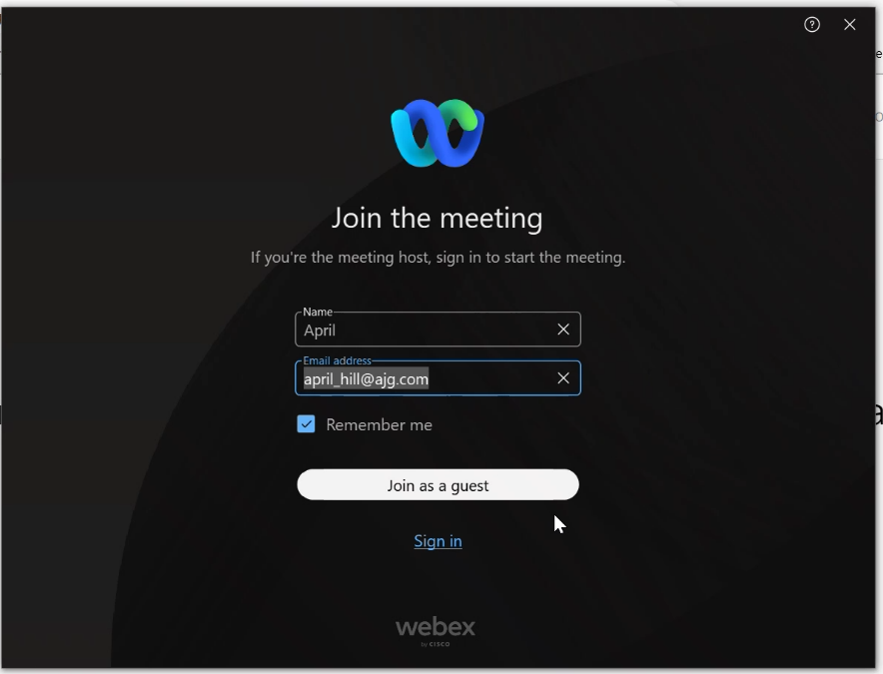If prompted enter your email address, check Remember me, and then click Next

1. If prompted enter the meeting password that's in your email invitation and then click Continue.
2. 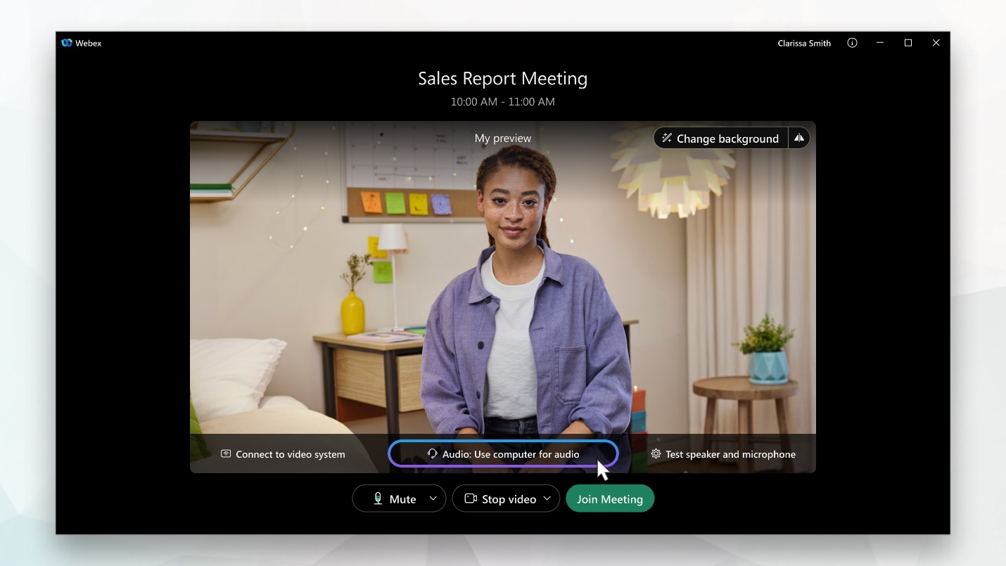In the preview window, you can make sure your audio and video sound and look good before you join the meeting.

First, choose how you want to hear:

**Use computer audio (default)** — Use your computer with a headset or speakers **OR Call in** — If you prefer to use your phone for audio, dial in when the meeting starts. A list of global call-in numbers appears after you join the meeting. Make a note of the access code or meeting number and the attendee ID. You'll need to enter these numbers to join the meeting.

1. Click Join Meeting

**Join from your browser:**

1. Open your email invite/calendar event and click the link to join meeting (should be a hyperlink – you can also copy and paste into an internet browser window)
2.  Webex starts preparing to connect you to your meeting. If you join from a Windows computer or Mac, click **Join from your browser**. If you join from a Linux computer or Chromebook, you won't be prompted to install anything. The meeting simply opens in your browsermeeting.
3. Enter your name as you want it to appear in the meeting and then click Sign in so you can access the full list of meeting features. **OR** if you just want to join the meeting quickly and don't need access to all the meetings features, click Join as a guest
4. If you're asked for a meeting password, enter the meeting password - it's in your email invitation - and click Continue
5. In the preview window, you can make sure your audio and video sound and look good before you join the meeting.

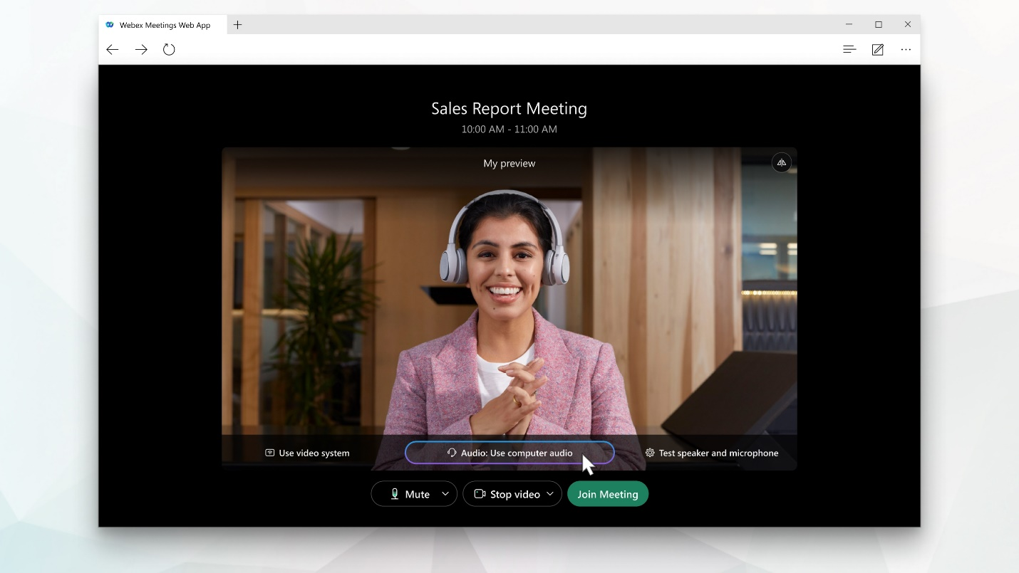First, choose how you want to hear:

Use computer audio (default) — Use your computer with a headset or speakers OR Call in — If you prefer to use your phone for audio, dial in when the meeting starts. A list of global call-in numbers appears after you join the meeting. Make a note of the access code or meeting number and the attendee ID. You'll need to enter these numbers to join the meeting.

1. Click Join Meeting

Virtual Backgrounds

Limit distractions and maintain privacy in your current surroundings by using a virtual background. You can blur your background, change your background, or add your own background.

On Mac or Windows, use virtual backgrounds in meetings, webinars, and events using the Meetings desktop app.

1. To set your virtual background **before you join** a meeting, click Change background (this can be found on the dropdown menu of your camera/video options) on the preview screen and choose the background that you want to use:
   * To blur your surroundings while remaining in focus, click Blur.
   * To use a default virtual background, click the one you want.
   * To use your own image for the virtual background, click the + icon.
2. To change your background **during a meeting**, click the Video options icon Video options icon, choose Change virtual background and select the type of background you want.
3. When you're ready for everyone in the meeting to see your background, click Apply.

Mute/Unmute Yourself

We have set most meetings to a mute on entry default setting. This will help with the quality of our workshops and webinars. There are several ways to participate in each interactive session.

1. 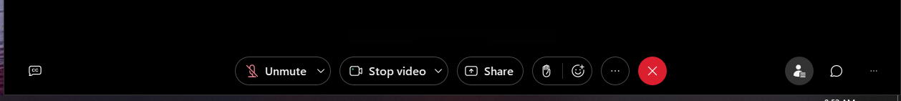Unmute – to speak please use the buttons found on the bottom of your meeting window and unmute yourself. Don’t forget to put yourself back on mute when you are finished
2. Raise Hand – if you would like a turn speaking or have a question you can raise your hand until the host calls on you – at which time you will unmute to participate. When your hand is raised it will turn yellow – when you would like to lower you hand click on the icon again.

Chat

If you would like to send a message in the chat, this function can be accessed on the toolbar at the bottom of your meeting window.

1. Click on the chat button





1. 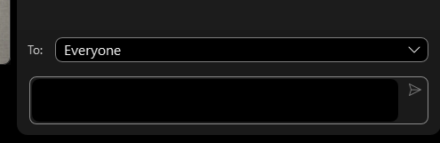Use the drop down to select sending a private message to another participant, sending a private message to the host, or sending a message to everyone.
2. 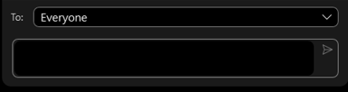Type your message in the text box and send

Closed Captioning

If you would like to use closed captioning during the meeting – you can turn on this function using the toolbar in the bottom of your meeting window. Click the CC button and then choose what language you would like text to appear. To turn off closed captioning use the same button.



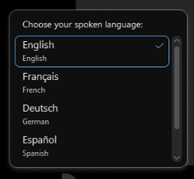

Audio Settings (Microphone Selection/ Noise Removal)

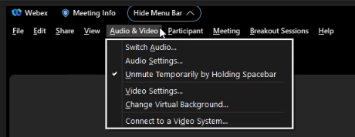Audio and microphone selection can be set before entering a meeting (as detailed above). If you would like to adjust any of these settings they can be accessed from within the meeting using the Audio & Video drop down on the top Menu Bar.

OR

Use the dropdown next to your microphone button on the bottom toolbar



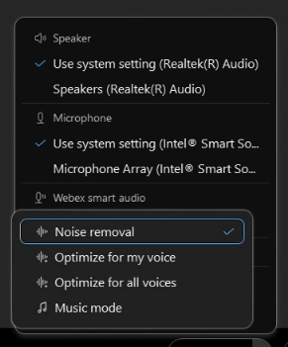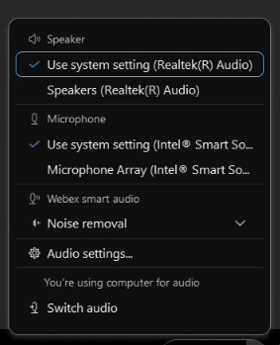

Camera Settings (Change Background/ Noise Removal)

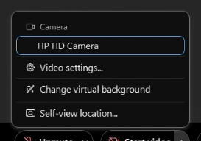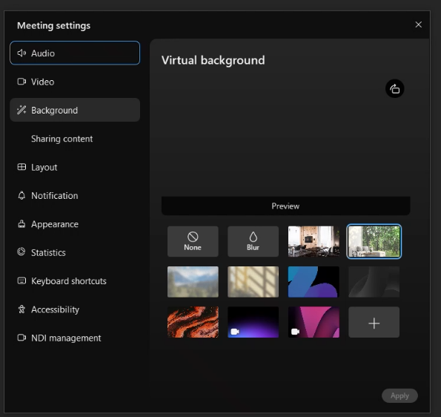Video, Camera, and Background selection can be set before entering a meeting (as detailed above). If you would like to adjust any of these settings they can be accessed from within the meeting using the Audio & Video drop down on the top Menu.

OR

Use the dropdown next to your camera button on the bottom toolbar



Leave Meeting

To Leave the meeting click on the red X on the bottom toolbar.

